Form 4
Capstone Design Implementation

Title : Integrated Operational Management System for C3MR:
Web Admin Portal & Telegram Mini App Ecosystem

GROUP MEMBER:
No. | Student Name | Student ID | Study Program
1. | Auza Syamil Nabawi (Leader) | 001202300150 | Informatics
2. | Rashad Abdul Faqih | 001202300149 | Informatics
3. | Atthariqul Hazam Albanna | 012202300122 | Information System

Advisor : Dr. Adhi Setyo Santoso, ST.MBA.

Submitted for
Capstone Design Project
Faculty of Computer Science
President University
2026

TABLE OF CONTENT
STATEMENT OF ORIGINALITY
SCREENSHOT OF ZEROGPT
PART 4 : IMPLEMENTATION
A. DESIGNS IMPLEMENTATION
A.1 Backend Implementation (FastAPI + SQLAlchemy)
A.2 Database Implementation
A.3 User Interface — Web Admin Portal
A.4 User Interface — Telegram Mini App
A.5 Security Implementation
A.6 Integration Among Modules
B. PRODUCT DISPLAY
B.1 Web Admin Portal
B.2 Telegram Mini App
B.3 Telegram Manager Bot
C. COMPONENT COST ANALYSIS
D. FUNCTIONAL TESTING
D.1 Manual Scenario Testing
D.2 Automated Test Suite (pytest) — 20 Test Cases
E. MANUAL GUIDE
E.1 System Build Documentation
E.2 End-User System Installation
E.3 User Guide Per User Role
REFERENCES

STATEMENT OF ORIGINALITY
In my capacity as an active student at President University and as the author of the Capstone Design Project stated below:

Name : 1. Auza Syamil Nabawi – 001202300150
2. Rashad Abdul Faqih – 001202300149
3. Atthariqul Hazam Albanna – 012202300122
Faculty : Computer Science

I hereby declare that my Capstone Design Project entitled "Integrated Operational Management System for C3MR: Web Admin Portal & Telegram Mini App Ecosystem" is to the best of my knowledge and belief, an original piece of work based on sound academic principles. If there is any plagiarism detected in this final project, I am willing to be personally responsible for the consequences of these acts of plagiarism and will accept the sanctions against these acts in accordance with the rules and policies of President University.

I also declare that this work, either in whole or in part, has not been submitted to another university to obtain a degree.

Cikarang, May 2026

Signer 1 | Signer 2 | Signer 3
Auza Syamil Nabawi  001202300150 | Rashad Abdul Faqih  001202300149 | Atthariqul Hazam Albanna  012202300122

SCREENSHOT OF ZEROGPT
[Insert ZeroGPT screenshot here]

PART 4 : IMPLEMENTATION
Consists of:
A. DESIGNS IMPLEMENTATION
B. PRODUCT DISPLAY
C. COMPONENT COST ANALYSIS
D. FUNCTIONAL TESTING
E. MANUAL GUIDE

A. DESIGNS IMPLEMENTATION

A.1 Functions/Procedure/Class Implementation — Backend
The C3MR backend is built using Python’s FastAPI framework with SQLAlchemy ORM for database operations. The application follows a modular router-based architecture where each domain (auth, dashboard, targets, users, analytics, officer) is separated into its own router module.

Main Application Entry Point (backend/main.py)
The FastAPI application is initialized in main.py. It configures restricted CORS middleware (origins controlled via CORS_ORIGINS environment variable), request logging middleware with duration tracking, mounts static file directories for photo uploads and the Telegram Mini App, and registers six API routers. A global exception handler prevents stack trace leakage in production.
app = FastAPI(title="C3MR API")
@app.exception_handler(Exception)
async def global_exception_handler(request, exc):
logger.error(f"Unhandled error on {request.url}")
detail = str(exc) if os.environ.get("DEBUG") == "true" \
else "Internal server error"
return JSONResponse(status_code=500, content={"detail": detail})
ALLOWED_ORIGINS = os.environ.get("CORS_ORIGINS",
"http://localhost:5173,http://localhost:3000").split(",")
app.mount("/officer-app", StaticFiles(directory="mini-app", html=True))
app.include_router(auth.router, prefix="/api/auth")
app.include_router(dashboard.router, prefix="/api/dashboard")
app.include_router(targets.router, prefix="/api/targets")
app.include_router(users.router, prefix="/api/users")
app.include_router(analytics.router, prefix="/api/analytics")
app.include_router(officer.router, prefix="/api/officer")

Authentication Router (backend/routers/auth.py)
Handles manager login via POST /api/auth/login. Accepts username and password, validates credentials against bcrypt-hashed passwords in the database, and returns a signed JWT token (HS256, 24-hour expiry) with user information. A one-time POST /api/auth/seed-admin endpoint creates the initial admin account using a server-side SEED_TOKEN for bootstrap security.
@router.post("/login", response_model=AuthResponse)
async def login(payload: LoginPayload, db: Session = Depends(get_db)):
user = db.query(DbUser).filter(
DbUser.email == payload.username).first()
if not user or not verify_password(
payload.password, user.password_hash):
raise HTTPException(401, "Invalid credentials")

Dashboard Router (backend/routers/dashboard.py)
Provides the GET /api/dashboard endpoint returning aggregated statistics (total, completed, in_progress, pending) and the targets list. Also provides GET /api/dashboard/recent-comments with a joined query (comments + users + targets) for the web admin’s activity feed.
@router.get("/", response_model=DashboardSnapshot)
async def get_dashboard_snapshot(db = Depends(get_db)):
total_targets = db.query(DbTarget).count()
completed = db.query(DbTarget).filter(
DbTarget.status == TargetStatus.completed).count()
targets = db.query(DbTarget).order_by(
DbTarget.created_at.desc()).limit(50).all()
return {"stats": {...}, "targets": targets}

Targets Router (backend/routers/targets.py)
Manages collection targets with JWT-protected endpoints. Key endpoints: GET /api/targets (paginated list with skip/limit and status filter), POST /api/targets/upload (bulk import from frontend CSV parsing), PATCH /api/targets/{id}/assign (assign officer with automatic Telegram notification), GET /api/targets/{id}/comments (joined query for officer feedback).
@router.patch("/{target_id}/assign")
async def assign_target(target_id, officer_id, db = ...):
db_target.assigned_officer = officer_id
db_target.status = TargetStatus.in_progress
db.commit()
if db_officer.telegram_id:
send_telegram_notification(db_officer.telegram_id, msg)

Users Router (backend/routers/users.py)
Manages user CRUD operations, protected by require_manager dependency (only managers can access). Includes Foreign Key cascade protection: before deleting a user, the system checks for associated targets, reports, and comments. If any exist, the request is rejected with HTTP 409 Conflict, requiring reassignment first.
# FK cascade protection before delete
has_targets = db.query(DbTarget).filter(
DbTarget.assigned_officer == user_id).first()
has_reports = db.query(DbReport).filter(
DbReport.officer_id == user_id).first()
has_comments = db.query(DbComment).filter(
DbComment.officer_id == user_id).first()
if has_targets or has_reports or has_comments:
raise HTTPException(status_code=409,
detail="Cannot delete user with assigned data")

Officer Router (backend/routers/officer.py)
Dedicated API for field officers via Telegram Mini App. Uses HMAC-SHA256 validation of Telegram initData for cryptographic authentication. File uploads are protected with extension whitelist (jpg, jpeg, png), 10MB size limit, and UUID filename generation to prevent path traversal attacks.
def get_current_officer(x_telegram_auth = Header(None), db = ...):
is_valid = validate_telegram_data(x_telegram_auth)
if not is_valid:
raise HTTPException(403, "Invalid Telegram Signature")
telegram_id = str(json.loads(parsed_data["user"]).get("id"))
return db.query(DbUser).filter(
DbUser.telegram_id == telegram_id).first()

Security Module (backend/security.py)
Implements dual authentication: JWT (HS256) for the Web Admin Portal with bcrypt password hashing, and HMAC-SHA256 validation of Telegram Mini App initData using constant-time comparison (hmac.compare_digest) to prevent timing attacks. Provides two access control dependencies: require_auth (any authenticated user) and require_manager (manager role only, returns 403 for officers).
def validate_telegram_data(init_data: str) -> bool:
parsed_data = dict(parse_qsl(init_data))
telegram_hash = parsed_data.pop("hash")
data_check_string = "\n".join(
f"{k}={v}" for k, v in sorted(parsed_data.items()))
secret_key = hmac.new(b"WebAppData",
bot_token.encode(), hashlib.sha256).digest()
calculated_hash = hmac.new(secret_key,
data_check_string.encode(), hashlib.sha256).hexdigest()
return hmac.compare_digest(calculated_hash, telegram_hash)
# Role-Based Access Control
require_auth = get_current_manager() # any valid JWT
require_manager = _require_manager_dep() # JWT + role == manager

Notification Service (backend/notifications.py)
Sends real-time Telegram notifications to officers when assigned a new target, using the Bot API sendMessage endpoint with Markdown formatting.

Manager Bot Service (backend/bot_service.py)
Standalone Telegram bot for managers using python-telegram-bot with long polling. Commands: /start (welcome + Mini App button), /summary (collection statistics), /officers (officer list with task counts). Uses @contextmanager pattern for database session management to prevent session leaks. Access control via require_manager() checks Telegram ID against registered managers in database.
from contextlib import contextmanager
@contextmanager
def get_db():
db = SessionLocal()
try:
yield db
finally:
db.close() # Always closes, even on exception
# Usage in every command handler:
async def summary_command(update, context):
with get_db() as db:
total = db.query(func.count(DbTarget.id)).scalar()
...

A.2 Database Implementation
The database uses SQLAlchemy ORM with dual-database support: SQLite for local development and PostgreSQL (Railway) for production. The DATABASE_URL environment variable controls which database is used. PostgreSQL connections enforce SSL (sslmode=require).

Entity Relationship Diagram
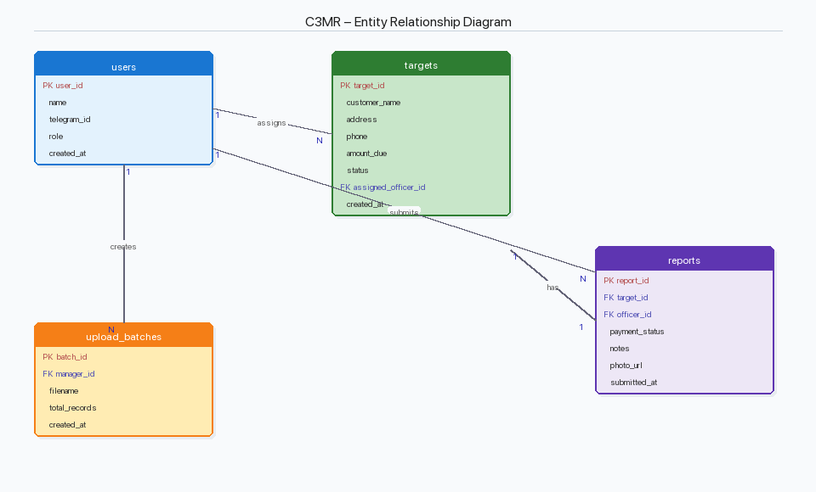
Figure A.2a — Entity Relationship Diagram
The database consists of four tables:
- users — Managers and field officers with optional Telegram ID linking, UUID primary key, name, email/username (unique), password_hash (bcrypt), and role enum (manager/officer).
- targets — Collection targets with customer data, FK assigned_officer → users.id, and status enum (pending, in_progress, completed).
- reports — Field reports with FK to targets and users, payment_status classification (Promise to Pay, Paid, Refused, Not Home, Partial Payment), notes, and photo_url.
- comments — Officer feedback with FK to targets and users, message text, and optional tag for categorization (wrong_address, wrong_phone, customer_moved, not_found, other).

SQLAlchemy ORM Models (backend/models.py)
class DbUser(Base):
__tablename__ = "users"
id = Column(String, primary_key=True,
default=lambda: str(uuid.uuid4()))
telegram_id = Column(String, unique=True, nullable=True)
email = Column(String, unique=True, nullable=True)
password_hash = Column(String, nullable=True)
name = Column(String, nullable=False)
role = _enum_col(UserRole, "user_role")
class DbTarget(Base):
__tablename__ = "targets"
id = Column(String, primary_key=True, ...)
customer_name = Column(String, nullable=False)
address = Column(String, nullable=False)
phone = Column(String, nullable=False)
amount_due = Column(Float, nullable=False)
assigned_officer = Column(String, ForeignKey("users.id"))
status = _enum_col(TargetStatus, "target_status")
class DbReport(Base):
__tablename__ = "reports"
target_id = Column(String, ForeignKey("targets.id"))
officer_id = Column(String, ForeignKey("users.id"))
payment_status = _enum_col(PaymentStatus, ...)
notes = Column(Text); photo_url = Column(String)
class DbComment(Base):
__tablename__ = "comments"
target_id = Column(String, ForeignKey("targets.id"))
officer_id = Column(String, ForeignKey("users.id"))
message = Column(Text, nullable=False)
tag = Column(String, nullable=True)

A.3 User Interface Implementation — Web Admin Portal
Built with React 18 + TypeScript, Vite build tool, Tailwind CSS, react-router-dom v7, Axios with JWT interceptors, Recharts for chart visualization, and PapaParse for CSV parsing. Includes an ErrorBoundary component for graceful error handling and automatic token expiry validation on page restore.

Page Components
LoginPage — Username/password login with password visibility toggle (eye icon), client-side brute force protection (5 attempts / 60-second lockout via localStorage), Recovery Options modal with admin reset and re-seed instructions, loading spinner animation, and automatic redirect if already authenticated.
DashboardPage — Summary cards (Total Targets, Completed, In Progress, Pending), completion chart via Recharts, recent officer comments feed, real-time data from API.
TargetsPage — Full target inventory with status filter, CSV upload panel with preview, officer assignment dropdown, View Details modal with officer comments and tag badges.
AnalyticsPage — Recharts pie chart for status distribution, revenue breakdown with collection rate, officer performance ranking table.
UserManagementPage — Officer registration form, officer table with Telegram ID, delete functionality with FK protection feedback (409 error display).

Login Page Security Features
// Client-side brute force protection
const MAX_ATTEMPTS = 5;
const LOCKOUT_MS = 60_000; // 60 seconds
// On failed login:
recordFailure(); // increment counter in localStorage
const remaining = MAX_ATTEMPTS - failures.count;
setError(`${message} (${remaining} attempts remaining)`);
// On 5th failure:
setError("Account temporarily locked. Try again in 60s.");
// Form inputs and submit button disabled
// On successful login:
clearFailures(); // reset counter

Authentication Context (AuthContext.tsx)
React Context API manages authentication state globally. On page load, readStoredUser() retrieves the JWT from localStorage, decodes the payload, and checks the exp field. If expired, the user is automatically logged out. The login() function stores authenticated user data, and logout() clears all stored state.

A.4 User Interface Implementation — Telegram Mini App
Single-page app built with vanilla HTML/CSS/JavaScript, served at /officer-app. Uses Telegram Web App SDK for native integration (haptic feedback, back button, main button). Includes localStorage-based offline caching with 24-hour TTL for tasks and comments.

Application Views
- Loading View — Animated spinner during initialization.
- Login View — Manual Telegram ID entry fallback for browser testing.
- List View — Assignment queue with task cards: case number, customer name, address, priority badge (red/yellow/blue based on amount), amount, 'Process Report' button.
- Detail View — Report form: subject data card, classification dropdown (Promise to Pay, Paid, Refused, Not Home, Partial Payment), officer narrative, photo capture, issue report section with tag buttons (Alamat Salah, Nomor Salah, Customer Pindah, Tidak Ditemukan, Lainnya), comment history, and 'Finalize Submission' button.

XSS Prevention
Because the Mini App uses vanilla JavaScript (not React’s auto-escape), a manual esc() function is implemented to prevent Cross-Site Scripting:
function esc(str) {
const d = document.createElement('div');
d.textContent = str; // Browser auto-escapes
return d.innerHTML; // Returns escaped string
}
// Usage: '<div>' + esc(task.customerName) + '</div>'

A.5 Security Implementation
As a cybersecurity-focused capstone project, the following security controls are implemented across the system, mapped to OWASP Top 10 2021 categories:
A01 Broken Access Control: Role-Based Access Control with two levels: require_auth (any valid JWT) and require_manager (JWT + manager role). Officers attempting to access manager endpoints receive HTTP 403. FK cascade protection prevents orphan data on user deletion (409).
A02 Cryptographic Failures: Bcrypt adaptive password hashing (cost factor 12). JWT HS256 token signing with server-side SECRET_KEY. HMAC-SHA256 Telegram initData validation with constant-time comparison (hmac.compare_digest) to prevent timing attacks.
A03 Injection: SQLAlchemy ORM ensures all queries are parameterized (prevents SQL injection). React auto-escapes JSX output (prevents XSS in Web Admin). Manual esc() function in Mini App prevents XSS in vanilla JavaScript rendering.
A04 Insecure Design: Structured input forms with dropdowns and enums (not free text). Pydantic server-side validation on all request bodies. File extension whitelist (.jpg, .jpeg, .png).
A05 Security Misconfiguration: CORS whitelist (not allow-all). DEBUG mode disabled in production. Secret keys via environment variables (not hardcoded). No stack traces in error responses.
A07 Authentication Failures: JWT 24-hour expiry. Bcrypt with adaptive cost factor. Client-side rate limiting (5 attempts / 60-second lockout). UUID primary keys prevent IDOR.
A08 Data Integrity Failures: HMAC-SHA256 validates Telegram data authenticity (anti-spoofing). UUID filenames prevent path traversal. 10MB upload limit prevents DoS.

A.6 Integration Among Modules

System Architecture
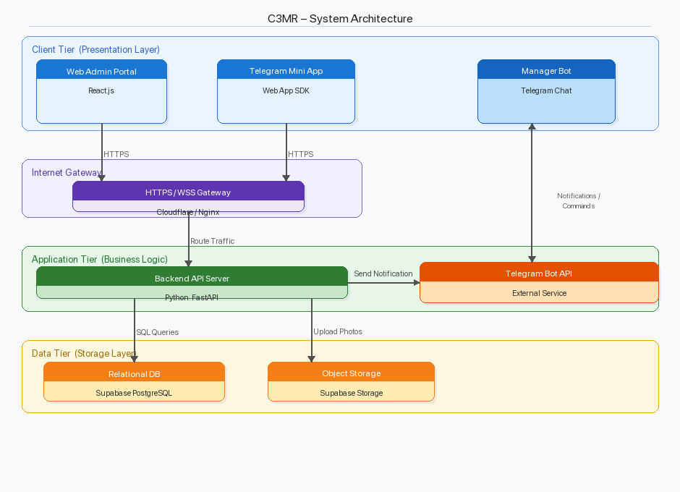
Figure A.6a — System Architecture Diagram (3-Tier)

Component Interaction
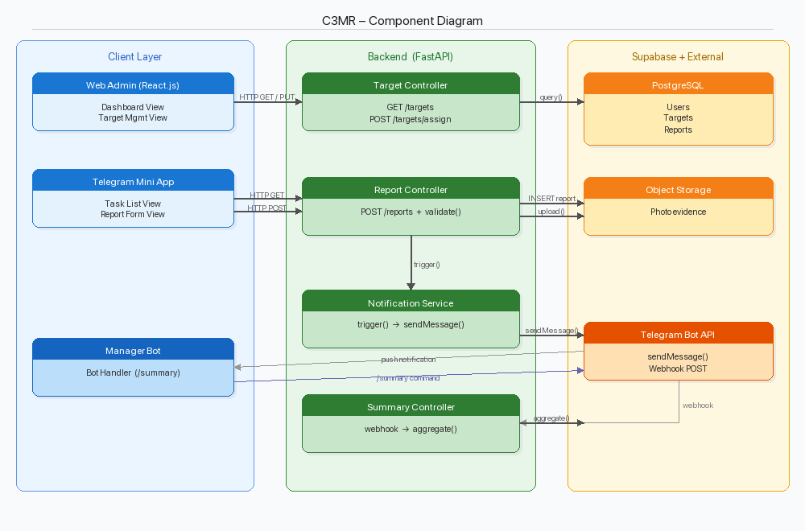
Figure A.6b — Component Diagram
1. Web Admin Portal ↔ Backend API: React frontend communicates via Axios RESTful calls through /api prefix. An Axios request interceptor automatically attaches the JWT Bearer token to every request. API base URL configured via VITE_API_BASE_URL environment variable, defaulting to /api for same-origin deployment.
2. Telegram Mini App ↔ Backend API: Uses Fetch API with X-Telegram-Auth header for cryptographic authentication. Accesses /api/officer/* endpoints for tasks, reports (multipart/form-data with photo), and comments.
3. Backend → Telegram Bot API: When manager assigns a target, backend sends push notification to officer’s Telegram via Bot API sendMessage. Manager Bot queries database for /summary and /officers using context manager pattern.
4. Shared Database Layer: All components share the same PostgreSQL database through SQLAlchemy ORM, ensuring data consistency. Changes in any interface are immediately visible in others.

B. PRODUCT DISPLAY

B.1 Web Admin Portal
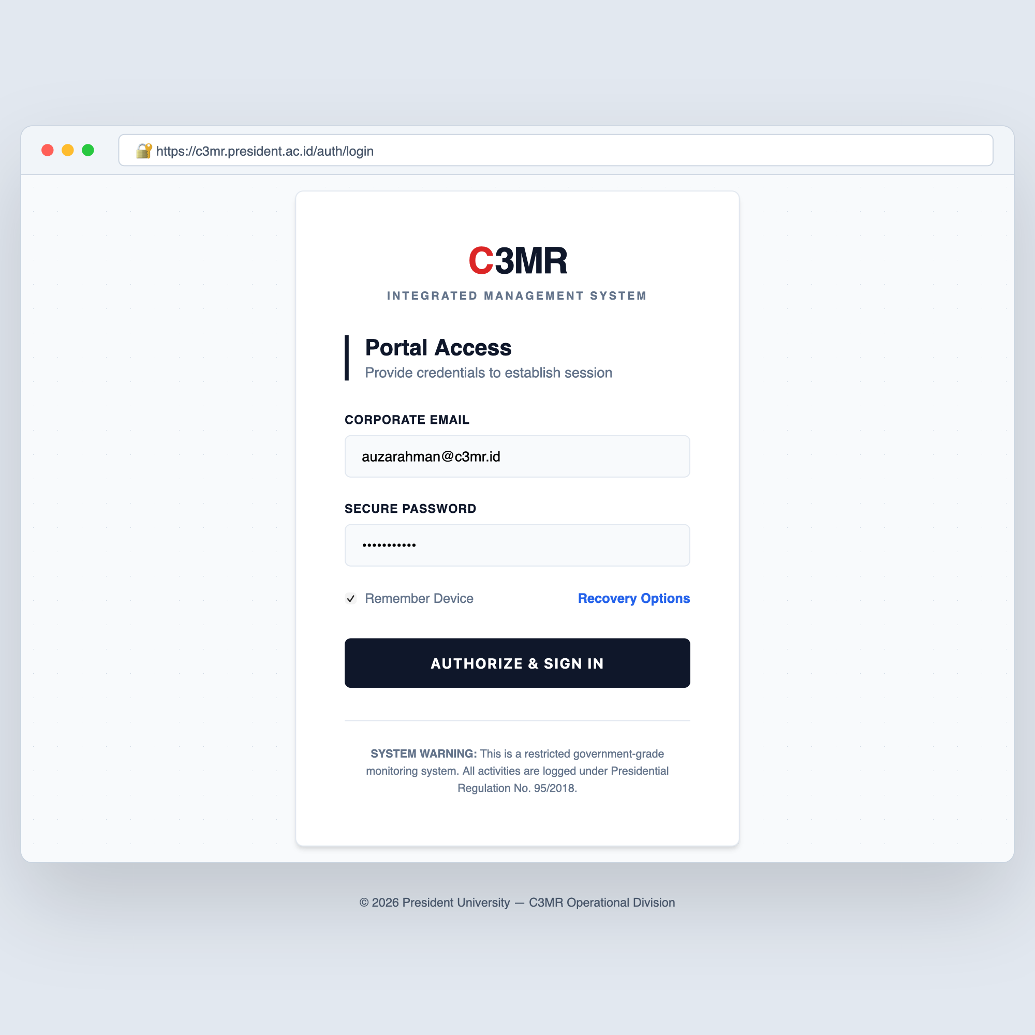
Figure B.1a — Web Admin Portal — Login Page
Features C3MR branding, username/password fields with password visibility toggle, 'Remember Device' checkbox, Recovery Options modal, and security notice. After 5 failed attempts, the form is locked for 60 seconds with countdown display.

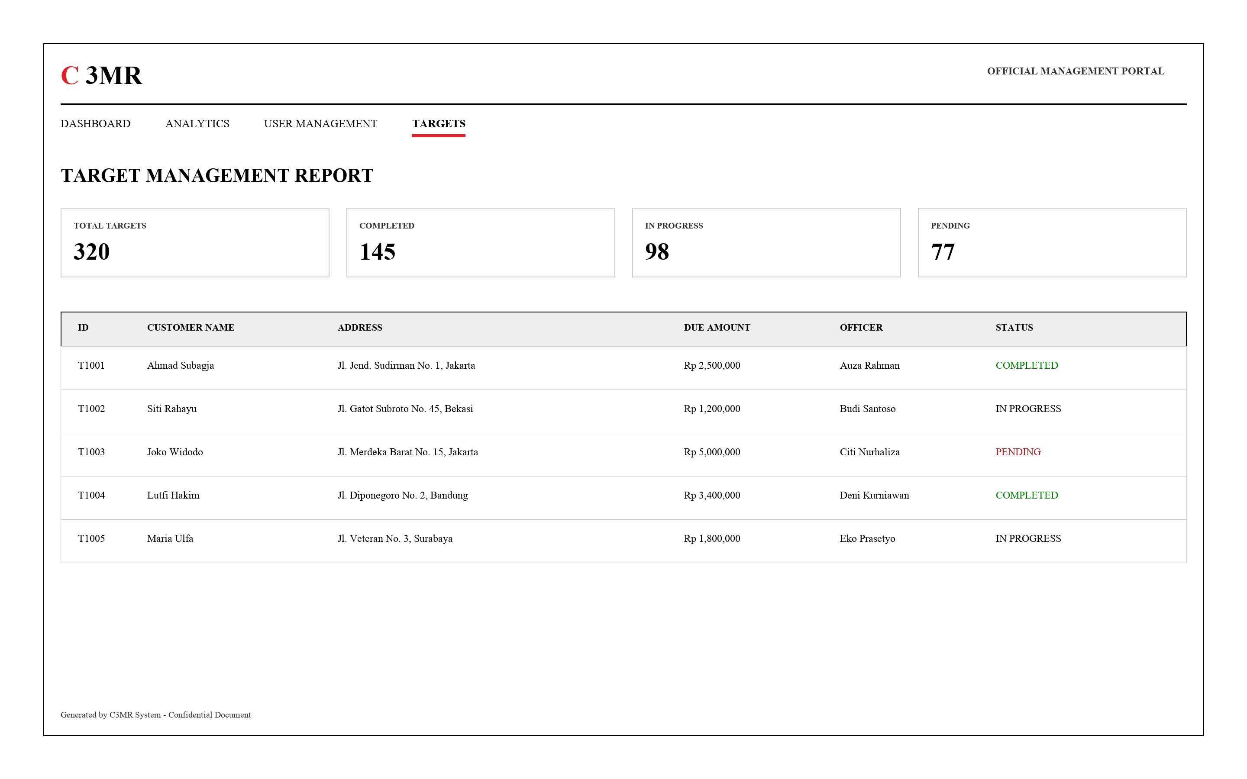
Figure B.1b — Web Admin Portal — Dashboard & Target Management
Four summary cards (Total Targets, Completed, In Progress, Pending), targets table with status badges, officer assignment dropdown, and CSV upload panel.

[Insert live screenshots of Analytics Page, User Management, and View Details Modal]

B.2 Telegram Mini App
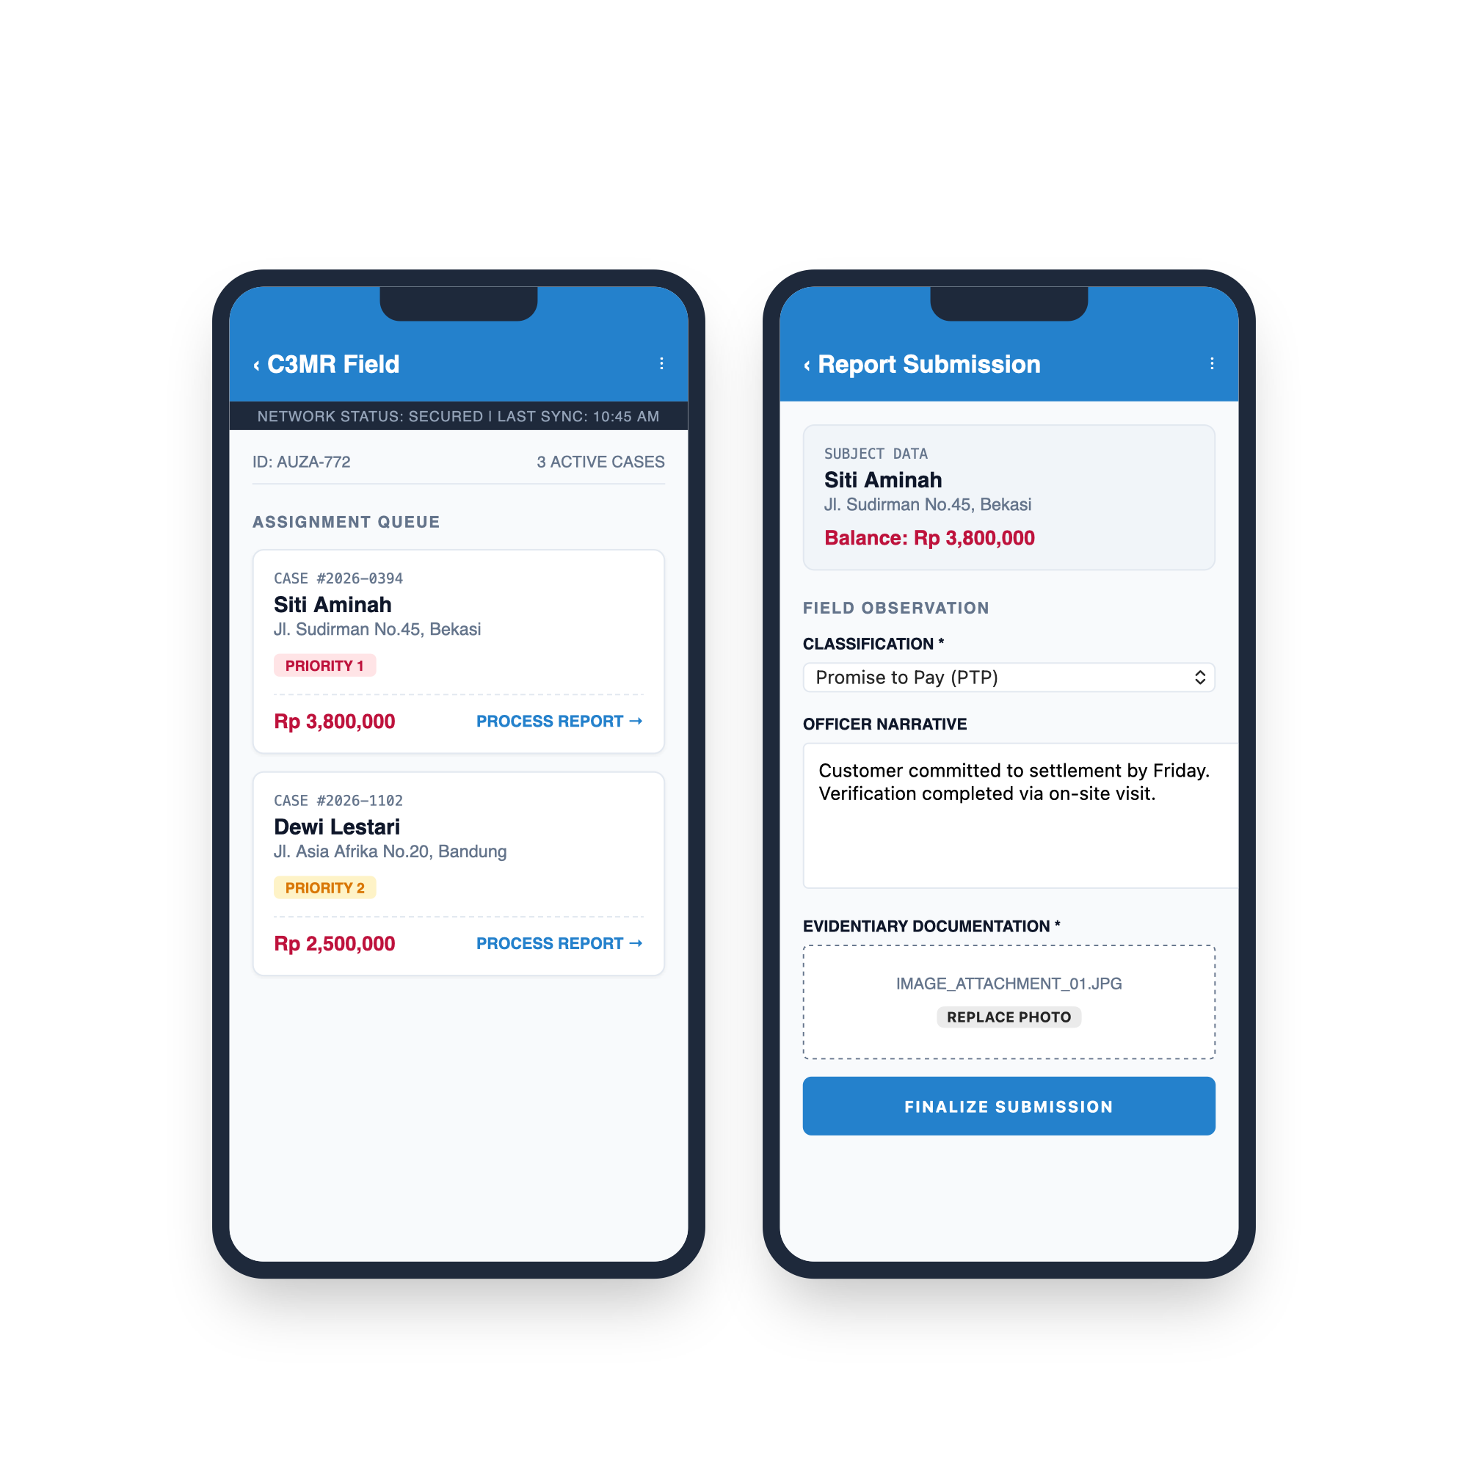
Figure B.2a — Mini App — Task List (left) and Report Submission (right)
Left: Assignment queue with task cards showing case number, priority badges (Priority 1/2/3), customer info, and amount. Right: Report form with classification dropdown, officer narrative, photo capture, and 'Finalize Submission' button.

[Insert live screenshots of comment system, offline mode, and submission success]

B.3 Telegram Manager Bot
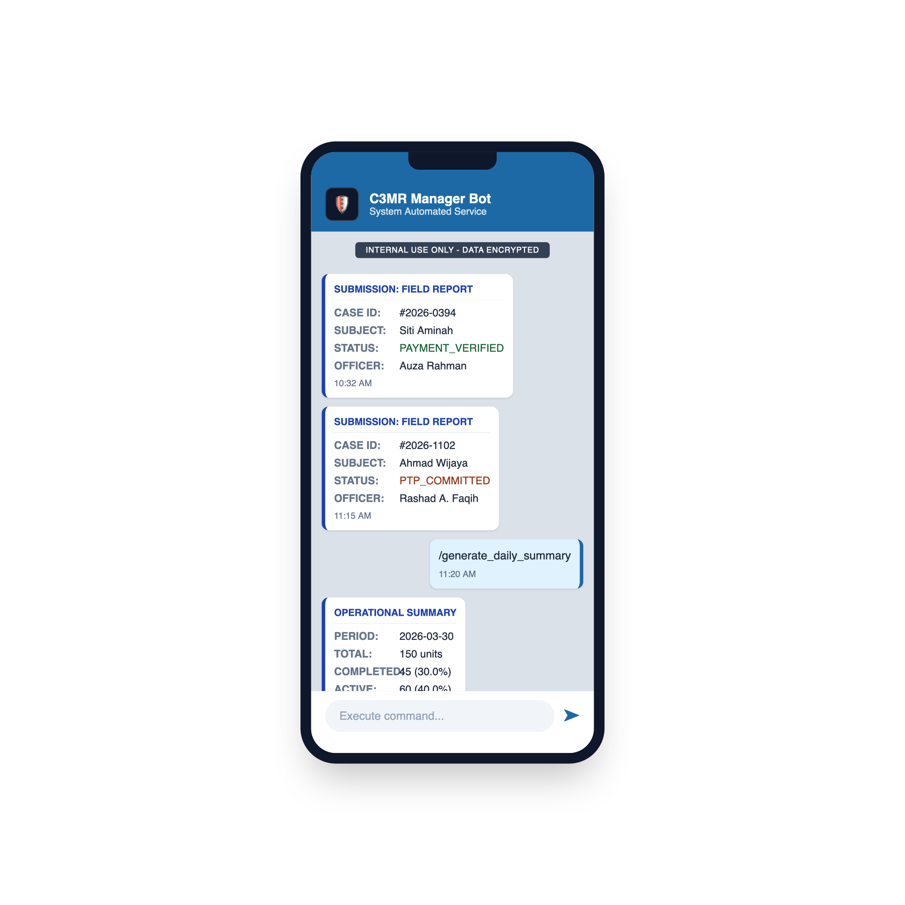
Figure B.3a — Manager Bot — Notifications and /summary Command
Shows submission field reports with case ID, subject, status, and officer name. The /generate_daily_summary command displays operational summary with period, total units, completed count, and active percentage.

C. COMPONENT COST ANALYSIS
The following table lists all necessary components for the C3MR system to operate in production.
No. | Item | Unit | Price per Unit | Total
1 | Railway Starter Plan  (Backend + Frontend + Bot) | 2 services/mo | $5/mo (~Rp 80,000) | Rp 80,000/mo
2 | Railway PostgreSQL  (Database add-on) | 1 instance | Included in plan | Rp 0
3 | Telegram Bot API | 1 bot | Free | Rp 0
4 | Custom Domain  (optional) | 1 year | ~Rp 150,000/yr | Rp 150,000/yr
5 | Development Laptop  (existing hardware) | 1 unit | Existing asset | Rp 0
6 | ngrok Free Tier  (development only) | 1 account | Free | Rp 0
7 | IDE & Dev Tools  (VS Code, Postman, Git) | Per developer | Free/Open Source | Rp 0

Total Estimated Monthly Cost: Rp 80,000/month (~$5 USD)
Total Estimated First-Year Cost: Rp 1,110,000 (~$69 USD)

D. FUNCTIONAL TESTING
Each feature is tested with both manual scenario testing (Section D.1) and an automated pytest test suite (Section D.2). The automated suite contains 20 test cases covering authentication, user management, target operations, dashboard, analytics, comments, security enforcement, RBAC, and FK cascade protection.

D.1 Manual Scenario Testing

Test 1: Manager Login Process
No. | Scenario | Every Possible Input | Expected Output | Result
1 | Valid credentials | Username: admin  Password: password123 | Redirect to Dashboard | PASS
2 | Wrong password | Username: admin  Password: wrongpass | Error: Invalid credentials  (4 attempts remaining) | PASS
3 | Empty fields | Username: (empty)  Password: (empty) | HTML5 validation blocks  submission | PASS
4 | Brute force (5 failures) | Wrong password 5 times | Account locked 60 seconds  Form disabled | PASS
5 | Lockout recovery | Wait 60 seconds after lock | Form re-enabled  Can try again | PASS

Test 2: Upload CSV Targets
No. | Scenario | Every Possible Input | Expected Output | Result
1 | Valid CSV | CSV with customer_name,  address, phone, amount_due | Targets imported,  appear in table | PASS
2 | Empty CSV | Headers only, no data | 0 records parsed | PASS
3 | Missing column | CSV without amount_due | Error: Missing required  columns: amount_due | PASS
4 | Non-CSV file | Upload .txt file | Error: Only .csv files  accepted | PASS

Test 3: Assign Officer to Target
No. | Scenario | Every Possible Input | Expected Output | Result
1 | Assign to target | Click Assign, select officer | Status → In Progress | PASS
2 | Officer with Telegram | Assign officer with telegram_id | Notification sent to officer | PASS
3 | Officer without Telegram | Assign officer, no telegram_id | Assignment OK, no notif | PASS

Test 4: Officer Views Task List (Mini App)
No. | Scenario | Every Possible Input | Expected Output | Result
1 | Open from Telegram | Tap Menu button in bot chat | Task list with priority cards | PASS
2 | Registered officer | Officer with telegram_id in DB | Cards with priorities shown | PASS
3 | Unregistered user | Unknown telegram_id | Error: Akses Ditolak | PASS
4 | No assigned tasks | Officer with 0 targets | 'No pending assignments' | PASS

Test 5: Officer Submits Report (Mini App)
No. | Scenario | Every Possible Input | Expected Output | Result
1 | Complete report | Classification + Notes +  Photo attached | Success alert, list refreshed | PASS
2 | No photo | Classification + Notes,  no photo | Error: Photo mandatory | PASS
3 | Status: Paid | Classification = Paid | Target → Completed | PASS
4 | Status: Refused | Classification = Refused | Target stays In Progress | PASS

Test 6: Officer Issue Comment (Mini App)
No. | Scenario | Every Possible Input | Expected Output | Result
1 | Comment with tag | Tag: Alamat Salah  Message: filled | Saved with tag badge | PASS
2 | Comment no tag | Tag: none  Message: filled | Saved without badge | PASS
3 | View in web admin | Manager opens target details | Comment with officer name shown | PASS
4 | Empty comment | Tag: selected  Message: empty | Error: Tulis komentar | PASS

Test 7: Manager Dashboard
No. | Scenario | Every Possible Input | Expected Output | Result
1 | Dashboard load | Navigate to /dashboard | Stats cards + table shown | PASS
2 | Filter by status | Select 'Pending' filter | Only pending targets shown | PASS
3 | Analytics page | Navigate to /analytics | Charts + revenue displayed | PASS
4 | Recent comments | Dashboard feed section | Latest 5 comments with names | PASS

Test 8: Manager Bot Commands
No. | Scenario | Every Possible Input | Expected Output | Result
1 | /start | Send /start to bot | Welcome + Open App button | PASS
2 | /summary | Send /summary | Stats: counts, revenue | PASS
3 | /officers | Send /officers | Officer list with task counts | PASS
4 | Unauthorized user | Non-manager sends /summary | Access Denied message | PASS

Test 9: User Management
No. | Scenario | Every Possible Input | Expected Output | Result
1 | Add officer | Name + Telegram ID | Appears in user table | PASS
2 | Duplicate Telegram ID | Existing telegram_id | Error: Already registered | PASS
3 | Remove officer (no data) | Click Remove, confirm | Deleted from table | PASS
4 | Remove officer (has data) | Officer with assigned targets | Error 409: Cannot delete  user with assigned data | PASS
5 | Officer access denied | Login as officer,  access /users/ | HTTP 403 Forbidden | PASS

D.2 Automated Test Suite (pytest) — 20 Test Cases
The project includes 20 automated API tests using pytest with FastAPI TestClient. Tests run against an in-memory SQLite database (StaticPool) that is created fresh for each test function, ensuring complete isolation. All tests include JWT authentication headers via the auth_headers fixture.

Test Configuration (backend/tests/conftest.py)
engine = create_engine("sqlite:///:memory:", poolclass=StaticPool)
# Override dependency: all endpoints use test DB
app.dependency_overrides[get_db] = override_get_db
# Fixture: fresh tables for each test
@pytest.fixture(scope='function', autouse=True)
def setup_db():
Base.metadata.create_all(bind=engine)
yield
Base.metadata.drop_all(bind=engine)
# auth_headers fixture: creates manager, logs in, returns JWT

Test Coverage (20 tests)
- Authentication (5 tests): seed admin (valid/invalid token), valid login, wrong password, nonexistent user
- User Management (3 tests): create/list, duplicate telegram_id rejection, delete user
- Targets (3 tests): upload/list, pagination (skip/limit), assign officer with status change
- Dashboard (2 tests): snapshot stats, recent comments with joined query
- Analytics (1 test): summary with revenue breakdown and distribution
- Comments (1 test): target comments with officer name
- Security (3 tests): officer tasks/report/comment without auth → 401 Unauthorized
- RBAC (1 test): officer login then access /users/ → 403 Forbidden
- FK Safety (1 test): delete user with assigned targets → 409 Conflict

Result: 20 passed, 0 failed.

E. MANUAL GUIDE

E.1 System Build Documentation from the Source
Developer perspective: tools, dependencies, and steps to build and run C3MR from source.

Prerequisites
- Python 3.10+ (recommended 3.12+)
- Node.js 18+ with npm
- Git version control
- Telegram account (for bot/Mini App testing)

Backend Setup
# Clone and install
git clone https://github.com/asn95/capstone1.git && cd capstone1
pip install -r requirements.txt
# Configure environment (.env)
DATABASE_URL=sqlite:///./c3mr.db
JWT_SECRET=<your-secret-key>
CORS_ORIGINS=http://localhost:5173
TELEGRAM_BOT_TOKEN=<your_token>
SEED_TOKEN=<your_seed_token>
# Start server (tables auto-created on first run)
uvicorn backend.main:app --host 0.0.0.0 --port 8000 --reload
# Seed admin account
curl -X POST http://localhost:8000/api/auth/seed-admin \
-H "Content-Type: application/json" \
-d '{"token": "<SEED_TOKEN>"}'

Frontend Setup
cd frontend && npm install
echo "VITE_API_BASE_URL=http://localhost:8000/api" > .env
npm run dev # Available at http://localhost:5173

Production Deployment (Railway)
railway login && railway link
# Set environment variables via Railway dashboard
# Push to GitHub -> Railway auto-deploys from Dockerfile
# Services: c3mr-app (Dockerfile), c3mr-bot (Dockerfile.bot)

E.2 End-User System Installation
C3MR is web-based and requires no software installation for end users.
Role | Hardware/Software | Network | Access
Managers  (Web Admin Portal) | Computer/tablet with modern browser  (Chrome, Firefox, Safari, Edge) | Stable internet (min 1 Mbps) | Navigate to deployed URL,  login with username/password
Field Officers  (Telegram Mini App) | Android/iOS smartphone  with camera | Mobile data or Wi-Fi | Open bot in Telegram,  tap Menu button
Managers  (Telegram Bot) | Smartphone with  Telegram app | Mobile data or Wi-Fi | Search bot, send /start

E.3 User Guide Per User Role

Role 1: Manager — Web Admin Portal
1. Login: Open the portal URL, enter username and password, click 'Authorize & Sign In'. Password visibility toggle available. After 5 failed attempts, account locks for 60 seconds.
2. View Dashboard: Four summary cards show target counts. Recent comments section shows latest officer feedback.
3. Upload CSV Targets: Use the CSV Upload panel. CSV must have columns: customer_name, address, phone, amount_due. Preview before confirming upload.
4. Assign Officer: Click 'Assign' on unassigned targets, select officer from dropdown. Officer receives Telegram notification automatically.
5. View Details & Comments: Click 'View Details' to see full target info and officer comments with issue tags.
6. Analytics: Navigate to Analytics page for status distribution chart and revenue figures.
7. Manage Users: User Management page: add officers with name/Telegram ID. Cannot delete officers with assigned data (must reassign first).

Role 2: Field Officer — Telegram Mini App
1. Open Mini App: Open the bot in Telegram, tap Menu button. Identity verified automatically via Telegram cryptographic signature.
2. View Assignments: Main screen shows task cards with case number, customer info, priority badge (by amount), and balance due.
3. Submit Report: Tap 'Process Report', select payment classification, write observation notes, capture photo evidence, tap 'Finalize Submission'.
4. Report Issue: Scroll to 'Issue Report' section, select tag (Alamat Salah, Nomor Salah, Customer Pindah, Tidak Ditemukan, Lainnya), write comment, tap 'Kirim Komentar'.

Role 3: Manager — Telegram Bot
/start: Welcome message with system description and 'Open Field App' inline button.
/summary: Collection statistics — target counts, revenue totals, active officers.
/officers: List of all officers with their assigned task counts.

REFERENCES
Bray, T. (Ed.). (2017). The JavaScript Object Notation (JSON) data interchange format (RFC 8259). IETF. https://datatracker.ietf.org/doc/html/rfc8259
Jones, M., Bradley, J., & Sakimura, N. (2015). JSON web token (JWT) (RFC 7519). IETF. https://datatracker.ietf.org/doc/html/rfc7519
Krawczyk, H., Bellare, M., & Canetti, R. (1997). HMAC: Keyed-hashing for message authentication (RFC 2104). IETF. https://datatracker.ietf.org/doc/html/rfc2104
Meta Open Source. (n.d.). React documentation. https://react.dev/
OWASP Foundation. (2021). OWASP Top Ten 2021. https://owasp.org/Top10/
Provos, N., & Mazieres, D. (1999). A future-adaptable password scheme. USENIX.
Pydantic. (n.d.). Pydantic documentation. https://docs.pydantic.dev/
Ramírez, S. (n.d.). FastAPI documentation. https://fastapi.tiangolo.com/
SQLAlchemy. (n.d.). SQLAlchemy documentation. https://docs.sqlalchemy.org/
Tailwind Labs. (n.d.). Tailwind CSS documentation. https://tailwindcss.com/docs
Telegram. (n.d.). Telegram bot API documentation. https://core.telegram.org/bots/api
Telegram. (n.d.). Telegram mini apps documentation. https://core.telegram.org/bots/webapps
Vite. (n.d.). Vite documentation. https://vitejs.dev/
bcrypt. (n.d.). bcrypt password hashing library. https://pypi.org/project/bcrypt/
PyJWT. (n.d.). JSON web tokens for Python. https://pyjwt.readthedocs.io/
pytest. (n.d.). pytest documentation. https://docs.pytest.org/
python-telegram-bot. (n.d.). python-telegram-bot documentation. https://python-telegram-bot.readthedocs.io/

